**Week 3 – Landing, Login, and Enrollment Pages Development**

Adam E. Svatek

The University of Arizona Global Campus

CST499: Capstone for Computer Software Technology (CSF2415A)

Professor Joseph Rangitsch

April 29, 2024

**How to Run a PHP File in** **XAMPP**

XAMPP is a local server that could be used to run PHP, MySQL, and other programs. After downloading and installing XAMPP, open up XAMPP and press the “Start” button for both Apache and MySQL, **Fig 1**. From here, I would open up Visual Studio Code and begin to write a PHP file that will be saved to the “htdocs” folder in the XAMPP folder on the C drive. To run this PHP file, (with XAMPP already running) go into your internet browser and type in, “localhost/” and the file name. For example, “localhost/CST_499_project/index.php” where CST_499_project is the folder and index.php is the file name.

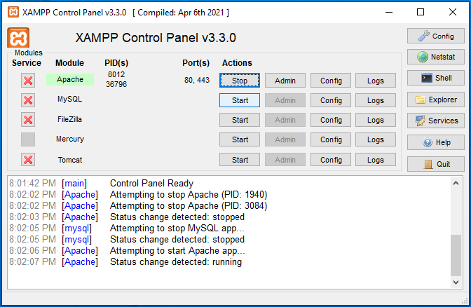

**Figure 1: Starting XAMPP**

**Create Landing, Login, and Registration Pages**

Figures 2, 3, and 4 are the landing page (home page), login page, and registration page.

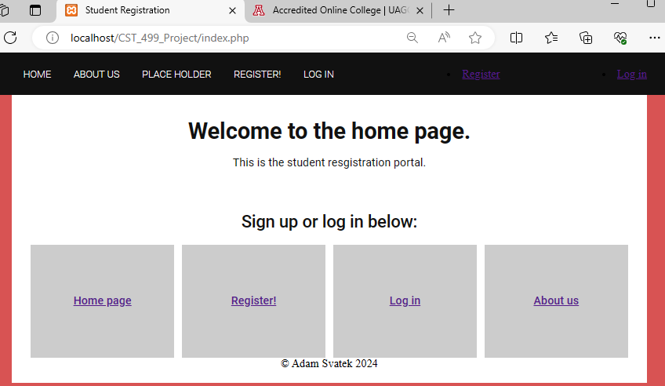

**Figure 2: Landing Page** 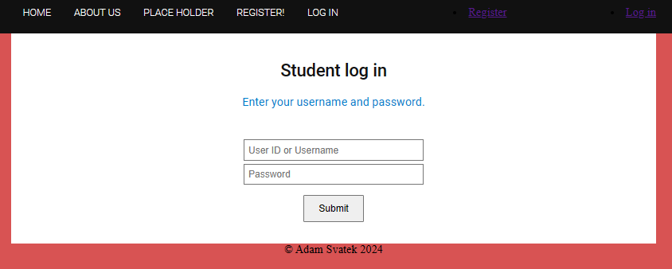

**Figure 3: Log In Page**

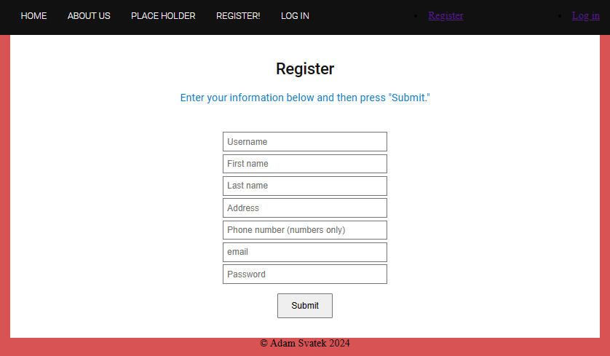

**Figure 4: Registration Page**

**Create MySQL Databases and Tables**

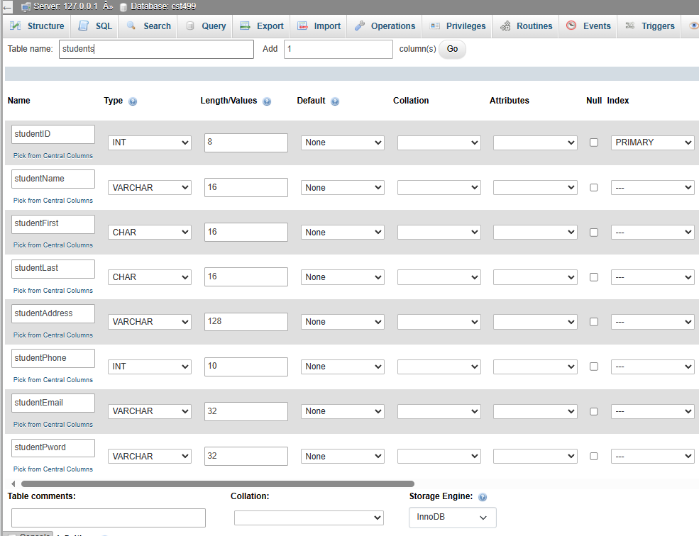

**Figure 5: Creating Student Databases**

**Discuss MySQL Database Functions Used**

Database functions used so far include CREATE TABLE, ALTER TABLE, and ADD PRIMARY KEY. The studentID should be an INT and will have the attribute AUTO_INCREMENT. This will make all student IDs unique and will auto populate starting with the lowest number available. MySQL code for the students database is shown in Figure 6.

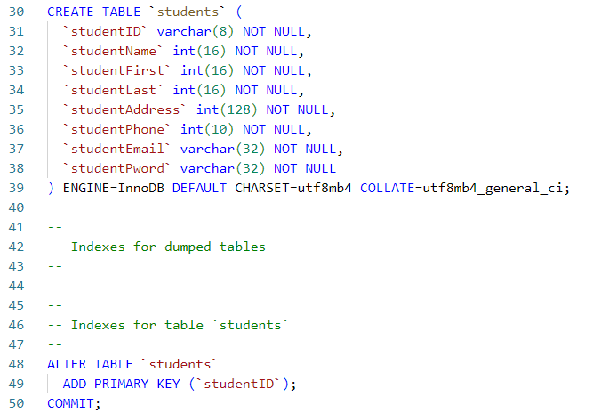

**Figure 6: Database SQL Code**

UML

**Develop the Registration Page Layout**

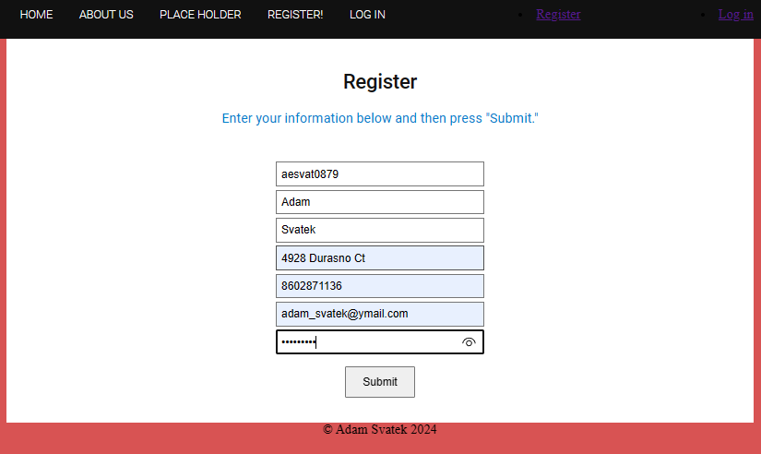

**Figure 7: Registration Page Layout**

**Develop the Registration Page PHP Code**

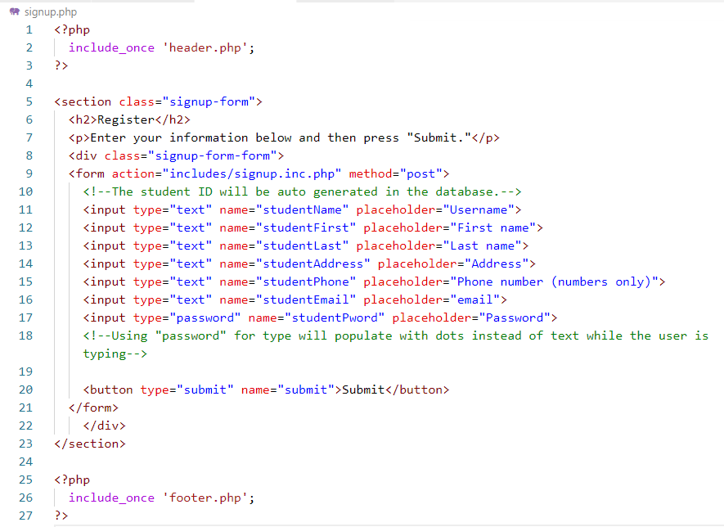

**Figure 8: Registration Page PHP Code**

**Develop the Table That Saves the User Information in the Database**

The registration page I created was not a table but a series of boxes where the user enters information, as seen in Figures 4 and 7. To create a table for this, I could use HTML code similar to what is shown in Figure 9, which results in the table in Figure 10. PHP code would be necessary to collect the data entered information.

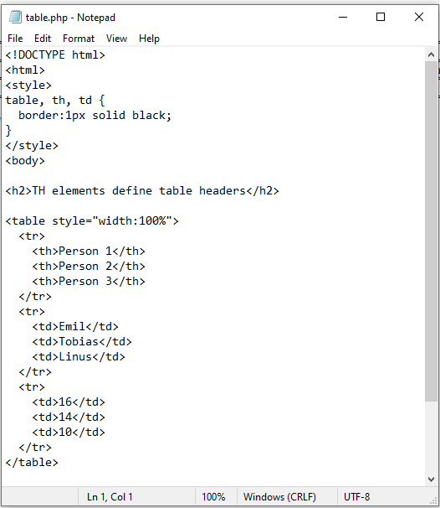

**Figure 9: Code for HTML Table**

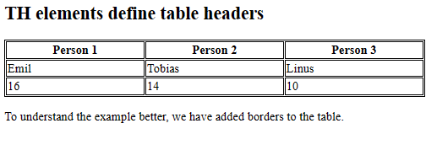

**Figure 10: Table Created from HTML Code**

**Explain Steps to Create a Registration Page and Save User Information**

To submit the user’s information to the database, I created the code in Figure 11 below that sends the information to the SQL file. I also added code that checks for empty inputs in any of these areas, as they were all NOT NULL in the SQL code. Lines 23-25 will check to see if the username already exists.

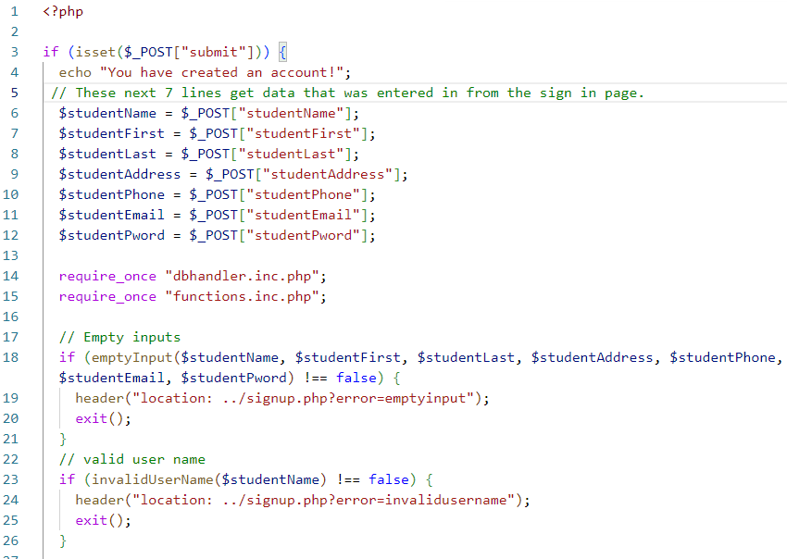

**Figure 11: PHP code to submit information to database**

**Provide Screenshots of All Developed Pages, Database, Tables, Layout, and Source Code**

Most of the pages, database, tables, layout, and source code has been provided above. In addition, I have source code for the header (Figure 12) and footer (Figure 13).

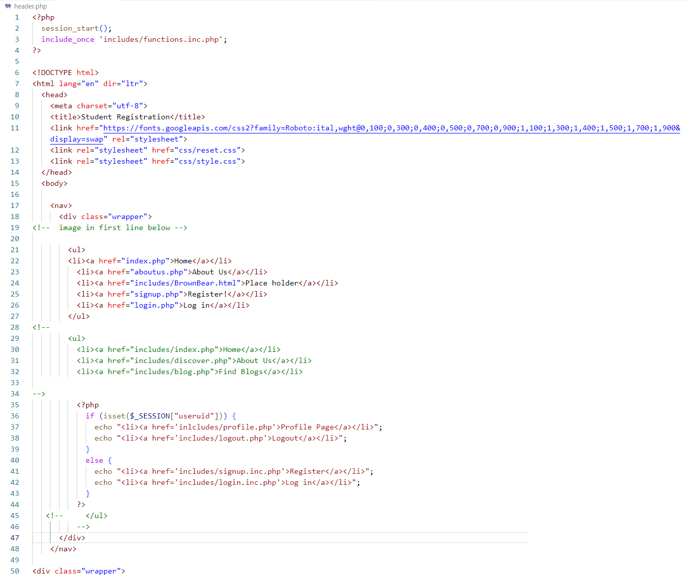

**Figure 12: Header**

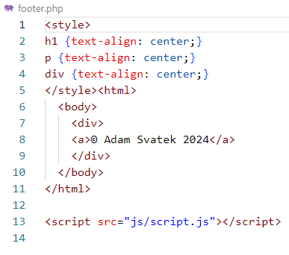

**Figure 13: Footer**

**References**

Connolly, R., & Hoar, R. (2018). Fundamentals of web development (2nd ed.). Pearson.

Krossing, D. (2023, August 31). PHP Course for Beginners. YouTube. https://www.youtube.com/playlist?list=PL0eyrZgxdwhwwQQZA79OzYwl5ewA7HQih

Sommerville, I. (2016). Software Engineering (10th ed.). Pearson.